Shopping

Here are a few money saving tips you can use when grocery shopping:
- When shopping in supermarkets and shops, always look up and down when walking through the aisles. Supermarkets will often put the more expensive products at eye level so that they catch your attention.
- Find out what time your local supermarket reduces the near to sell by goods. They will usually do it the same time every day. If your schedule allows, try shopping later to catch the bargains.

- Don’t be afraid to try cheaper brands. If the taste is not as good, why not try adding herbs and spices to savoury items?

- Where you can, try cooking larger quantities and freeze or keep for the next day. Not only can the ingredients be cheaper if you buy in larger quantities, but you will save on gas/electric too. Have you tried a pressure cooker or a slow cooker?

- Use cold hard cash on the shopping trip and leave your debit/credit card at home so you can’t overspend.

- Buy fruit and vegetables when they’re in season and it works out cheaper e.g. strawberries are cheaper in the summer.
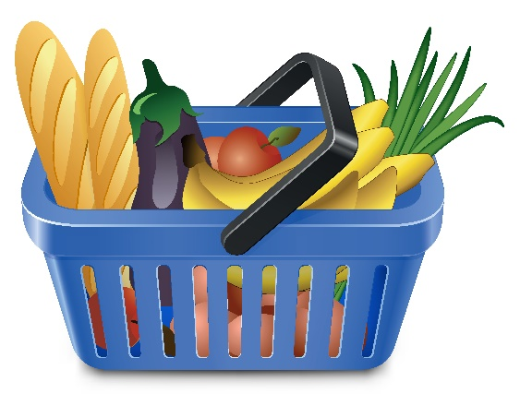
- When you do a top up shop, keep to a list and always use a basket. When the basket is full and it’s hard to carry, head to the checkout. Yes, it’s easy to grab one of the smaller trolleys and start adding items but you could soon end up throwing in loads of things that you just don’t need.

- Some larger supermarkets offer hand held scanners that you can use as you add to your trolley, this will keep an eye on your total spend as you shop.

- Compare the cost of your online shopping items at the major supermarkets at www.mysupermarket.co.uk

- Use a bag for life or recycle your old carrier bags rather than paying for new bags each time you go shopping, saving a few pence here and there whilst also helping to reduce plastic pollution.

- Shop around, don’t try to buy everything from one shop, often toiletries and cleaning products will be cheaper elsewhere.

- Take advantage of special offers on certain products like 2 for 1 or half price.

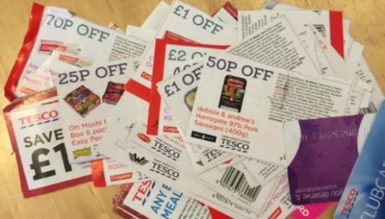
- Keep a look out for money off coupons in newspapers and magazines. Cut out and keep in your purse ready for your next shopping trip.

- Join loyalty card schemes, swipe your card when you spend, save up your points and get money back in vouchers or money off when you have enough. For example the Iceland bonus card gives you £1 back for every £20 spent, You can also pay a small amount onto your card each time you go shopping and save it all up to spend at Christmas.

- If you are on a low income and struggling to afford food, you may be entitled to a foodbank voucher, please visit www.trusselltrust.org to find out if you qualify and to find your nearest food bank.

- Consider buying your clothes from cheaper outlets such as EBay, Shpock, Charity shops, Facebook buy and sell sites. You can also sell/donate your unwanted items there too!

Meal Planner

A weekly meal planner can be useful when grocery shopping and can avoid wasting food. Here is an example of a basic weekly food planner.
 | Breakfast | Dinner | Tea
Monday
Tuesday
Wednesday
Thursday
Friday
Saturday
Sunday

Budget Recipes

Chickpea and Aubergine Curry, 66p - Serves four from 66p each
2 large onions, 22p (90p/kg)
6 cloves of garlic, 10p (20p/bulb)
40g fresh ginger, 12p (£1.50/500g)
1 tbsp lemongrass paste, 18p (£1.27/90g)
4 small red chillies, 12p (35p/12 approx)
1 tbsp cinnamon, 2p (65p/100g)
1 tsp cardamom, 5p (£1.49/50g)
400ml coconut milk, 50p (50p/400g)
2 tbsp lemon juice, 5p (39p/250ml)
400g chickpeas, 33p (33p/400g)
1 large aubergine, 70p (70p/each)
2 tomatoes, 25p (75p/6pk)

- First peel and finely slice your onions. Toss half of them into a blender or food processor, and leave the other half in a bowl to one side to use later.
- Peel and slice your garlic and add to the blender. Finely slice your ginger and add that too. Measure in the lemongrass, and add the chillies, cinnamon, cardamom and lemon juice. Pour in half the coconut milk, and blend to a thick paste.
- Heat a little oil in a large nonstick pan and add the remaining onions. Pour over the curry paste and bring to a medium heat, and stir. Drain and thoroughly rinse the chickpeas and add to the pan. Stir in the remaining coconut milk, then refill the coconut milk can with cold tap water to add as the curry starts to thicken, so it doesn’t dry out. Cook on a low heat for 30 minutes, adding a little water here and there to keep it wet but not sloppy.
- After 30 minutes, very finely slice your aubergine with a large heavy chefs knife so that the slices are almost transparent. This will take a little time and patience, so you can just dice it if you’re in a hurry, but I like the way the thin slices break down and almost disappear into the sauce, the only evidence of them being the traces that cling to the dark purple skin swirled throughout the dish. But if you are less poetically inclined towards your dinner, just chop it up and bung it in.
- Dice the tomatoes and add along with the aubergine, and cook for a further ten minutes. Serve hot with bread or rice, or whatever takes your fancy.

South Indian Inspired Egg Curry, 57p - Serves 4 from 57p each
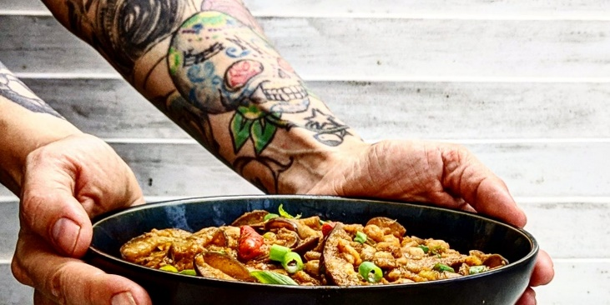

Serves four from 66p each.

2 large onions, 22p (90p/kg)
6 cloves of garlic, 10p (20p/bulb)
40g fresh ginger, 12p (£1.50/500g)
1 tbsp lemongrass paste, 18p (£1.27/90g)
4 small red chillies, 12p (35p/12 approx)
1 tbsp cinnamon, 2p (65p/100g)
1 tsp cardamom, 5p (£1.49/50g)
400ml coconut milk, 50p (50p/400g)
2 tbsp lemon juice, 5p (39p/250ml)
400g chickpeas, 33p (33p/400g)
1 large aubergine, 70p (70p/each)
2 tomatoes, 25p (75p/6pk) – not a traditional ingredient in a rendang but I felt it was missing something by using jackfruit in place of beef, so added them here.

- First peel and finely slice your onions. Toss half of them into a blender or food processor, and leave the other half in a bowl to one side to use later.
- Peel and slice your garlic and add to the blender. Finely slice your ginger and add that too. Measure in the lemongrass, and add the chillies, cinnamon, cardamom and lemon juice. Pour in half the coconut milk, and blend to a thick paste.
- Heat a little oil in a large nonstick pan and add the remaining onions. Pour over the curry paste and bring to a medium heat, and stir. Drain and thoroughly rinse the chickpeas and add to the pan. Stir in the remaining coconut milk, then refill the coconut milk can with cold tap water to add as the curry starts to thicken, so it doesn’t dry out. Cook on a low heat for 30 minutes, adding a little water here and there to keep it wet but not sloppy.
- After 30 minutes, very finely slice your aubergine with a large heavy chefs knife so that the slices are almost transparent. This will take a little time and patience, so you can just dice it if you’re in a hurry, but I like the way the thin slices break down and almost disappear into the sauce, the only evidence of them being the traces that cling to the dark purple skin swirled throughout the dish. But if you are less poetically inclined towards your dinner, just chop it up and bung it in.
- Dice the tomatoes and add along with the aubergine, and cook for a further ten minutes. Serve hot with bread or rice, or whatever takes your fancy.

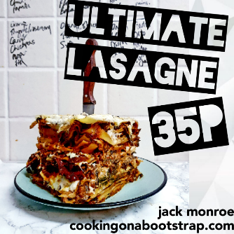
Lasagne, 35p Serves 6-8 from 35p each
1 onion, 6p (54p/1kg)
6 cloves of garlic, 10p (69p/4 bulbs)
150g dried green or red lentils, 27p (£1.80/1kg)
400g mushrooms, 85p (85p/400g)
100g spinach, kale or other greens , 17p (£1.50/900g)
100ml red wine, 33p (£2.50/750ml)
400g chopped tomatoes, 30p
1 tsp herbs, 4p (70p/15g)
1 tbsp gravy granules, 1p (20p/200g)
1 packet lasagne sheets, 50p (50p/500g)
For the white sauce:
1 tbsp flour, 1p (45p/1.5kg)
1 tbsp oil or butter sub, 1p (£1.10/1l)

200ml milk, 11p (55p/1l) – you can substitute with any plant milk to make it vegan, I recommend cashew for a creamy sauce!
½ tsp mustard, 1p (55p/180g)

- First peel and very finely chop the onion and garlic. Toss into a large pan with the oil and salt, and bring to a medium heat for a few minutes.
- Meanwhile, thoroughly rinse your lentils under a cold tap for a few minutes, and then add to the pan. Pour in the wine and tomatoes, add the herbs, and give it all a good stir before turning up the heat until it comes to the boil, then turn it down again to a medium simmer.
- Finely chop the mushrooms, add those to the pan too with the gravy granules and spinach.
- In a small, separate pan, heat the oil, flour and mustard together and stir briskly to form a rough paste. Add a splash of milk to loosen it, and another, and another, stirring all the time. Gradually add the milk until it is all incorporated, and leave it to cook on a low heat for around 10 minutes, where it will thicken considerably.
- Now turn your oven on to 180C, and grab a suitable dish, one that looks like it will hold the same amount of lentil-mushroom-ragu that you have. Spread a layer of ragu into the bottom of the dish to cover it. Lay lasagne sheets over the top, leaving no gaps between them if you can help it. Spread a thin layer of white sauce onto the dry pasta. Then repeat: ragu, pasta, sauce, until the ragu is all used up. Top with a final layer of pasta sheets, then a generous layer of white sauce, carefully spreading it right to the edges. Bake for 40 minutes, until golden and crisp around the edges.

Meatballs, 51p
Makes approximately 24, from 51p/serving.

1 x 400g tin of baked beans, 23p
1 onion, 5p (54p/1kg)
a pinch of chilli powder, <1p (£1.15/100g)
2 slices of bread, 4p (36p/loaf)
a handful of fresh parsley – optional
1 tbsp flour, 1p (45p/1.5kg)
500g turkey mince, £2.70
2 tbsp oil, to cook them, 3p (£1.10/1l)

- First drain and thoroughly rinse the beans to remove the majority of the tomato sauce. Folks often wonder why I do this; value range baked beans are a third of the price of their plain equivalents, and underneath the saccharine sticky orange sauce, they’re just a humble haricot bean, and can be used in a variety of recipes. They do retain a slightly orange hue, because as any parent knows, that stuff stains! But they are just fine to use here.
- Pop your newly nude beans into a small saucepan and cover with water. Bring to the boil, then reduce to a simmer for 5-10 minutes, until very soft and tender. Drain them well and tip into a mixing bowl, and mash to a pulp.
- Peel and very finely chop the onion, and toss into the bowl with the bean pulp. Grate in the bread, and finely chop the parsley and add that too.
- Spoon in the flour, and chilli, salt and pepper if using, and stir to combine. Add the mince and mix well with a wooden spoon, or if you don’t mind getting a little sticky, use your hands.
- Flour or lightly oil your hands to stop the mixture from sticking to it, and then shape it into little balls. A tablespoon is enough to make a decent sized ball, and bear in mind the larger they are the longer they will take to cook through!
- Fry in a frying pan in a little oil on a high-medium heat, turning occasionally to cook evenly, until cooked through, and then serve.

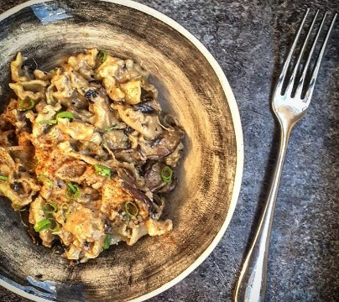
Mushroom Mac ‘n’ Cheese, 42p
Serves three people, or two particularly hungry ones, at 42p each

1 onion, 9p (90p/1.5kg, Sainsburys)
1 tbsp sunflower oil, 3p (£3/3l)
A pinch of salt, 1p (25p/1kg, Sainsburys Basics)
1 tbsp flour, 2p (65p/1.5kg)
400ml milk – or vegan equivalent, 18p (44p/1l)
150g mushrooms, 36p (97p/400g, Sainsburys Basics)
Half a ball of mozzarella, 22p (44p, Sainsburys Basics)
- First peel and finely chop your onion and sling it in a saucepan with a slug of oil.
- Cook on a gentle heat for a few minutes to soften, season with salt, and sprinkle in the flour. Mix briskly so that the flour coats the onions.
- Add a liberal splash of milk and beat well to form an oniony paste. Add another splash of milk, and another, keeping it moving so it doesn’t catch and burn, nor go stiff and sticky.
- Repeat until all the milk is used up; it will be quite runny at this point, but it will firm up in the oven later.
- Finely slice your mushrooms
Add your cheese (or cheese equivalent), dollop in the mustard, crank the heat up, and stir through until melted.
- Remove the pan from the heat, and fold in the pasta.
- Tip it into an ovenproof dish, making sure the pasta is pretty much covered in the sauce, add more cheese on top, and optional breadcrumbs if you like that kind of thing, and pop it in the oven at 180C for 45 minutes.

200g pasta (I used ‘gigli’ as it was a birthday present, but am pricing it up as a cheaper option as fancy frilly pasta is not essential!) 14p, (35p/500g Sainsburys Basics)
15g hard strong cheese, 18p (£2.30/200g, Sainsburys Basics)
A slice of bread, 2p (40p/22 slice loaf, Sainsburys Basics)

Pearl Barley, Mushroom & Lentil Risotto, 44p

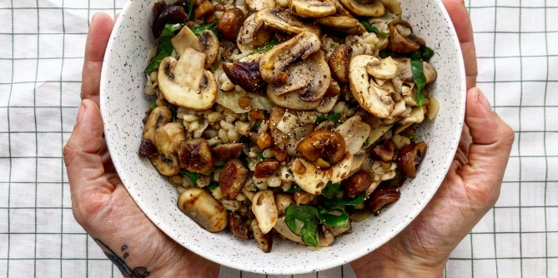
Serves 4, generously, from 44p each.
1 large onion, 9p
1 tbsp light cooking oil, 2p
6 fat cloves of garlic, 10p
Salt and pepper, to season, <1p
200g pearl barley, 22p
500ml vegetable or chicken-style stock, 3p
1 tbsp lemon juice, 2p
1 tsp mixed dried herbs, 4p
1 x 400g tin of brown or green lentils, 55p
400g mushrooms, 54p
250ml water
100g spring greens or other leafy green veg, 12p
Optional: 180g cooked chestnuts

- First peel and finely dice your onion. Add the onion to the pan, and measure in 1 tbsp light cooking oil.
- Peel your garlic cloves and quarter them lengthways, and add to the pot.
- Bring to a medium heat on your largest hob ring, and cook for around five minutes, stirring intermittently, to start to soften.
- Bring to a medium heat on your largest hob ring, and cook for around five minutes, stirring intermittently, to start to soften.
- Pour in the pearl barley and stir through, then pour over the stock. In reality, I crumble in the stock cube and pour over the water, and it all turns out fine, but some people like to make the stock in advance and add it.
- Bring to the boil, then reduce to a simmer. Add the lemon juice and herbs and stir well, then simmer for 25 minutes, until the water is all absorbed.
- Drain and thoroughly rinse your lentils, and add to the pan. Slice your mushrooms finely and add those too.
- If you have opted for chestnuts, crumble some up and leave some whole, and add them here. Fold through, and add another 250ml water. Bring back to the boil, then simmer again for another 15 minutes, until the pearl barley is soft. Finely slice your greens and drop them into the pan a couple of minutes before the end, to soften them but not overcook.

