Borrowing

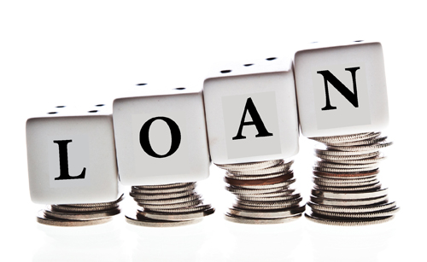
When borrowing money, don’t simply look for a loan with the lowest monthly repayment. Before you sign on the dotted line, it’s essential that you know the total cost of repaying the debt.
What is the ‘true cost of borrowing’?
The true cost of borrowing takes into account:
- The loan amount.
- The length of the borrowing term.
- The frequency of repayments.
- The rate of interest you’ll be charged.
- The cost of any fees and works out the total amount that you will have to pay to the lender.
Deciding on the loan amount
Before you go ahead and borrow any amount of money there are some important questions you need to ask yourself;
- Is whatever you want to spend the money on absolutely essential?
- Could you either save up or use savings instead of borrowing?
- How much can you afford to repay? (This is a much better question than ‘how much do you need to borrow?’)
How long do you need to borrow the money for?
Make sure you choose the shortest term you can manage.
Longer-term loans with lower monthly repayments may seem more appealing, but they are far from ideal. Your total repayment will be higher, as you are taking longer to clear the loan while the interest stacks up.
In the example below, you’d end up paying back £677 more if you go for the five-year term rather than the three-year term.
Loan term Amount borrowed APR Monthly repayment Total amount to repay
3 years £5,000 11.72% £165.40 £6,631
5 years £5,000 11.72% £110.52 £7,298
It’s far better to opt for a shorter loan term and pay back more each month, if you can afford to. Don’t just pay the minimum payment!

So-called ‘minimum payments’ on credit cards can be a debt trap. The minimum payment is the lowest amount you have to pay every month to avoid a fine. It’s usually based on a percentage of the balance and so decreases every month as your balance reduces, meaning it takes longer to clear your debt.
If you only make the minimum monthly repayments, it will take you much longer to pay off the balance and cost you far more in the long run.
For example, if you borrow £2,000 on a 19% APR and only pay the minimum payment every month:
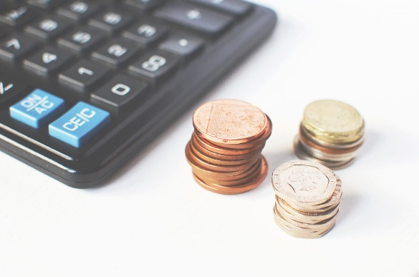
- It will take you 24 years and 2 months to repay it.
- You’ll pay back £4,731 in total.
- The total interest you have to repay will be £2,731.
How often will you need to make repayments?
Opt for regular repayments over lump sum payments. If you choose to repay a loan in one lump sum rather than make regular repayments, you’ll typically end up paying more in interest.
Work out the interest you’ll have to pay
Make sure you understand the APR. Interest is usually expressed in terms of APR, which stands for ‘annual percentage rate of charge’ and includes arrangement fees and charges. You can use it to compare different credit and loan deals, for example by using a price comparison website.
Generally speaking, the lower the APR, the lower the cost of borrowing, and therefore the better the deal. However, be aware that loan providers only have to offer the advertised APR to just over half (51%) of borrowers they lend to.
Fees – remember to take them into account
Fees may not feature prominently in the headline quote when you search for credit on comparison sites. However, it’s important to check for any fees, such as late payment, default, or settlement charges, as these can make a huge difference to the total cost of credit
0% Balance Transfers and Purchases
Please visit www.moneysavingexpert.com/credit-cards to find the latest deals on credit cards, some of which have 0% interest for a fixed period and no fees.

Peer to Peer Lending
A way for people to lend money to an individual or business without involving a financial institute e.g. bank or building society. The lender will receive interest from the borrower until the loan is repaid. The interest rates vary significantly depending on the borrower’s risk factor (credit rating). The loan is organised through a lending site. Reputable sites will be regulated by the Financial Conduct Authority (FCA).
Pros
- Loans can be cheaper than banks if you have a very good credit rating.
- Some have no minimum loan amount unlike mainstream lenders.
- An option if you have difficulty getting a loan based on your credit rating.
Cons
- Interest rates can be higher if you have a poor credit rating.
- You may have to pay a fee to the platform arranging the loan.
- You may not be eligible of you have a poor credit rating.
- If you default your debt maybe passed onto a debt collection agency.
- Missing payments will affect your credit rating in the same way other loans do.
Cost
- As a borrower interest rates can be as low as 3% if you have an excellent credit rating. Or as high as 30% if your credit rating is poor.
- The lending peer to peer platform also generally charge a fee for arranging the loan.
- As a lender you may also have to pay the platform a fee.
- Money earned is classed as income and will be taxable above the personal allowance.

Some popular platforms include

Peer to Peer lender platforms should be a member of the P2P finance association. This ensures that they abide by certain rules and regulations and that they must have been trading for at least six months.
To find out more information or to search for a lender please visit:

www.p2pfa.org.uk

