Universal Credit

As part of the Government’s ongoing reform of the welfare system, working age benefits are changing for some new claimants.
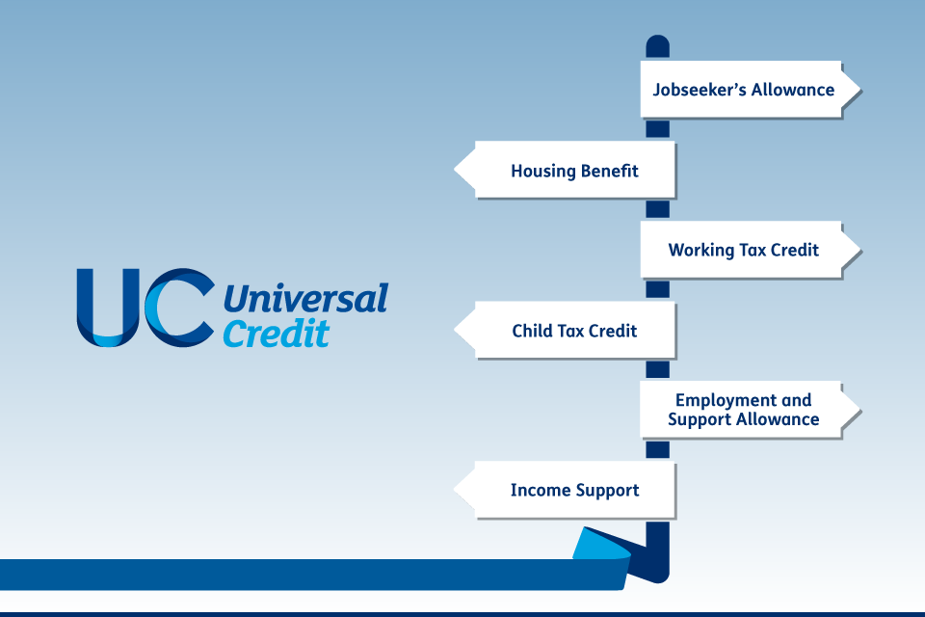
Universal Credit replaces the following benefits:
- Income-related Jobseeker's Allowance
- Income-related Employment Support Allowance
- Housing Benefit
- Income Support
- Working Tax Credit
- Child Tax Credit
Please note: You cannot claim Universal Credit if you: are getting the severe disability premium or got the severe disability premium within the last month and you’re still eligible for it.
Claiming Council Tax Reduction - If you are applying for Universal Credit you will no longer automatically receive Council Tax Credit. You will need to complete a separate council tax reduction application.
New style benefits - For those who may be entitled to contribution-based ESA and JSA, which is now known as New Style ESA and New Style JSA, we recommend that you call the Universal Credit helpline.
If you already receive benefits - If you’re already claiming benefits you don’t need to do anything - your local Job Centre Plus or Tax Credits office will tell you when you have to move to Universal Credit.
Universal Credit is claimed online. The payment is made monthly in arrears and paid to the bank account of one designated member of your household. If you need to claim housing benefit, this will be paid directly to you instead of your landlord.
Please note: People are currently waiting 4 to 6 weeks to receive their first UC payment.

If you need help to pay your bills or cover other costs while you wait for your first Universal Credit payment, you can call the Universal Credit helpline to apply to get an advance on your first payment.

Be Prepared!
To help you prepare for monthly payments we recommend you pay a small amount each week or month to bring your rent account into one month's credit.
By building up one month's credit on your rent account it will help you to budget and stop rent arrears. Rent arrears can put you at risk of losing your tenancy.
Please visit www.rightsnet.org.uk/resources/benefit-tax-credit-rates for a full list of benefits.
Benefit checks can be carried out at

For how to claim Universal Credit visit:
www.gov.uk/universal-credit
Universal Credit Helpline Telephone: 0800 328 5644 (Free)
Text phone: 0800 328 1344 (Free)
Phone lines open Monday to Friday, 8am to 6pm
You Tube Tutorial - www.youtube.com/watch?v=4WgJU8Y_bQg

