Moving On, Moving In

Moving house can be a very stressful and expensive time, here are some tips to help reduce stress and costs.

Top 10 last-minute questions to ask sellers
To make your life easy, remember to ask the previous owner these questions:
- Where's the main stopcock (to shut off the water)?
- Where are the gas and electricity meters?
- Do any surfaces need special cleaning products, e.g. wooden floors?
- What day are the bins collected?
- Do you have any old tins of paint in the same colour as the walls?
- Do you have any instruction manuals or warranties on electrical items?
- Where did the kitchen and bathroom tiles come from?
- Where does any fixed furniture come from, e.g., kitchen cabinets?
- Which company supplies the energy, broadband and home phone?
- Where is the thermostat?
It's a lot to remember, so why not write them down (or print off this guide) and take them with you so you don't forget?

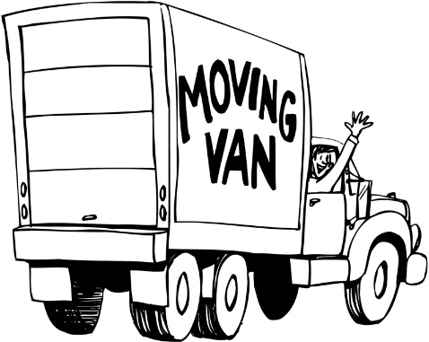
Compare removal costs
If you're moving without any furniture, (e.g., from your parents' home, or you've been renting a furnished property), a car and a couple of mates will suffice. Even if you think you have a lot of stuff, hiring a van for a couple of hours might work out cheaper than a removal company. Try Travelsupermarket, Enterprise Car Club or Zipcar if it operates near you.
For those who are moving from one furnished property to another, you'll probably need to enlist the help of a removal company.
To get five local quotes instantly, head to Reallymoving.com. Also check that the company belongs to the British Association of Removers.

Redirect your post
If you don't know who is moving into the property you are leaving, use the Royal Mail's Postal Redirection service to ensure that any bills or other mail you've not changed your address on still reaches you.
You can get post redirected for three, six or 12 months, and longer if you're still getting volumes of post through after your initial period is up. It costs from £33.99 (for three months), but if more than one person needs their mail redirecting the price is greater.
Remember that if mail isn't redirected, you need to call the sender and either update your address or ask to be taken off its mailing list.
It's important to do this - any bills you don't get and therefore don't pay can damage your credit record, or result in you being traced by a debt collection company. Stray letters can also increase the risk of ID fraud.

Top tips to make moving day go smoothly
Moving is one of the most stressful things you can do, but a little planning can help ensure you're not tearing your hair out on the day:
- Label all boxes with which room they're due to go to, and a description of what's inside. Put these labels on the top and side of the box so you know what's inside when they're stacked.
- Put screws and bolts from bits of furniture in freezer bags and stick it to the relevant bit of furniture with masking tape.
- Flatten some cardboard boxes and lay them down to protect your flooring.
- Move your furniture into the new house first, otherwise you'll end up moving boxes around again to make room.
- Make sure there are lightbulbs - you don't want to have to go to the shops mid-move or not notice until suddenly it's too dark.
It might seem like a bit of extra work beforehand, but you'll be thankful for it when it comes to unpacking at the other end.

Get free sofas, beds, TVs, fridges and more
Furnishing your new pad? Hundreds of top-quality goodies are available daily for free. It's all about web communities, and the big names are Freecycle and Freegle.

What's the catch? There isn't one. Instead of dumping goods or eBaying them, people harness the web's power to offer them to their local communities. As well as getting free good, the environment benefits as unwanted items aren't flung into landfills.
Of course, there is some inferior goods. But there's also top-quality stuff too. Bagging the best is all about the etiquette - you need to give yourself time to do your research and keep your eyes peeled. For a full step-by-step guide, see Freecycle & Freegle Tips.

Save £100s on your gas and electricity bill
Don't stick with the previous owners' energy supplier any longer than you have to. Those on providers' standard tariffs can save £100s a year by switching.
You can still compare, even if you don't have previous bills from your new house. Just say if you are a high, medium or low user to get the cheapest quotes.
This won't be 100% accurate as it makes some assumptions. But it'll give you good options, and could be far cheaper than the default standard tariff you'll be put on when you moved in.
Finally, don't forget to take meter readings when you move in. Then you'll know you're not being billed for the previous owner's usage. Make sure you read the meters on your previous property too.

Register to vote
When you move, you don't automatically get registered to vote at your new address. If you aren't registered, you don't get a say on who represents you.
It can also help boost your credit score as if you're not on the electoral roll it's unlikely you'll get accepted for credit. This is because credit reference agencies use the register to confirm where you live in order to counteract fraud.
The registration process now requires that, rather than one person registering all members of a household, each individual needs to register themselves. You can register on the gov.uk site.

Deal with old residents' post the right way
You open the front door on moving day and there's a pile of post that isn't yours on the doormat. You can't open it (legally) and shouldn't chuck it.
Your best bet is to write on it 'return to sender, not known at this address' and pop it back in the post. That way the sender will know not to send any future mail, and can try to find the new correct address from the recipient.

Buying a House
Slash your boiler cover costs
If there's a central heating boiler in your new pad, then consider getting insurance cover. There's nothing worse than arriving home when it's cold to discover the central heating's packed up and there's no hot water. Everything else flies out the window while you frantically search for someone who'll fix it - and it won't be cheap. As companies play on this by charging a lot of money.
Bag free £300 insulation for your new pad
If you receive certain benefits, there may be funding available to install loft or cavity wall insulation. These can cut bills by £300/yr. Each normally costs about £150. But to fulfil energy efficiency obligations, some firms do it free. Please visit www.freeinsulationgrants.co.uk for more information.
You usually have to be receiving child tax credit and have an income of £16,010 or under, or be on benefits such as pension credit, to qualify.
A quick way to check if you qualify is to call the Energy Saving Trust on 0300 123 1234 (England), 0800 512 012 (Wales) or 0808 808 22 82 (Scotland).

Check 'n' challenge your council tax band
Up to 400,000 homes in England and Scotland may have been in the wrong band since the early '90s. If you live in one of those homes, you can get your band lowered and a backdated payout. First see if neighbours in identical or similar properties are in lower bands, via the Valuation Office Agency or Scottish Assessors Association.
Then use the web to value your house for free, and convert it back to its 1991 price. See the Council Tax Reclaiming guide for the full reclaiming process.

Rent out your spare room for extra cash

If you have a spare room and fancy making some extra cash, you could always rent it out. If you do, you've two options to legitimately reduce tax, but you must choose one of them:
- The Rent a Room scheme: The Rent a Room scheme means you can take in a lodger to live in a furnished room in your home. It has a special exemption, meaning you won't have to pay tax on the first £7,500 you make each year. This is a huge tax break for most people and really ups the gain. Better still, as a landlord you'll be expected to ask for a month in advance, which means ready cash comes in quickly.
- Deducting expenses: HMRC also allows landlords to deduct mortgage interest costs and certain other expenses from any rental income. This can be a bigger saving in some cases. See Gov.uk for full info.
If you don't want to rent out a room full-time, you can play guesthouse. Airbnb and Wimdu let you list your spare room online, and take in travellers looking for a cheap place to stay. You can set the nightly cost, undercutting the local hotels, and you might just get to work on your language skills too.

Can you buy the freehold to your place?
Considering buying a leasehold flat? Some freeholders charge £10,000s in management fees for things you could do for a fraction of that. Luckily, in England and Wales, owners are often entitled to buy freeholds at a fair price - reducing outgoings and potentially adding to the sale value.
Buying freehold, if you can, costs about the same as extending your lease by 90 years and you can usually then extend the lease for free, just paying legal fees. For a full how-to, read the Buy Your Freehold guide.
As inspiration, here's MoneySaver westernpromise's experience:
We saved £700 on insurance in the first year. We bought a share of the freehold because the freeholder was charging us £1,000/year for buildings insurance. When we bought our own, it fell to £300/year. The freehold cost £1,500 per flat, including legal fees.
"We also gained control over maintenance expenses. Before this, the freeholder would dismiss suggestions that she was forcing us to overpay and just hand us a huge bill."

Give yourself a full money makeover
Moving house is the perfect time to assess your finances. You'll be signing up to new services anyway, so could save £1,000s on your previous bills by ensuring you grab everything cheapest.
For starters, find the cheapest line rental and Cheapest Broadband, energy, insurance at any of the following websites:

www.uswitch.com
www.moneysupermarket.com
www.comparethemarket.com

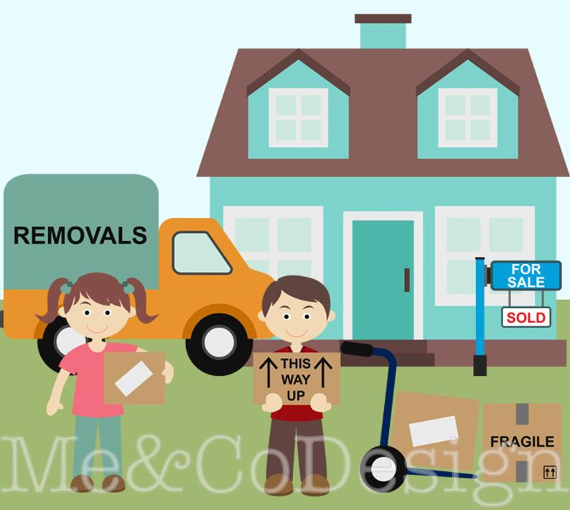

List of essentials to keep handy on moving day

Item | Tick
Kettle
Tea, coffee, sugar, milk
Flask of hot water
Bottle of drinking water
Cups, plates, cutlery, tin opener
Bedding
Towels
Scissors
Toiletries (don’t forget the toothpaste!)
Cash - coins and notes
Light bulbs
Small tool kit
Torch
Pen and paper
Keys
First Aid kit
Pet food
Other

Who to Notify Checklist
Health | Registered no | Telephone | Date contacted | Contact name | Tick
Doctor

Dentist

Orthodontist

Optician

Healthcare

Health Insurance

National Blood Bank

Other

Motoring | Account/ref no | Telephone | Date contacted | Contact name | Tick
DVLA – registration

Vehicle insurance

DVLA -
Driving licence

Breakdown services

Other

Financial | Account no | Telephone | Date contacted | Contact name | Tick
Bank / building society
Home insurance
Inland Revenue
Credit
cards
Store
cards
Savings account
Employer - payroll
National Insurance
Benefit Agency
Jobcentre
Child Benefit
Child Tax Credits
Catalogues
Hire Purchase / rental
Other
Services | Account no | Telephone | Date contacted | Contact name | Tick
Council Tax

Electoral Register

Water supplier

Electricity supplier

Gas
supplier

Home landline provider

Mobile provider

TV/Internet provider

TV Licensing

Post Office - redirect mail

School / college

School meals

Other

Other | Account/ref no | Telephone | Date contacted | Contact name | Tick
Library

Subscriptions

Mail Order/catalogue

Memberships

Unions

Other

