Best Before, Sell by and Use by dates
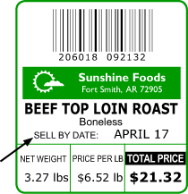
Making sense of the label

The ‘display until’ or ‘sell by’ dates are aimed at the shopkeepers rather than the shoppers. They indicate how long the food should remain on sale.

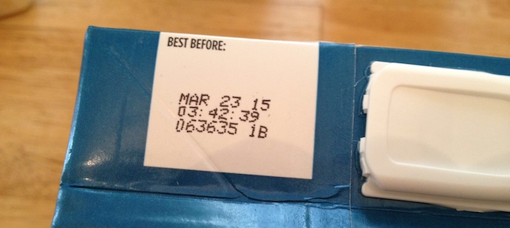
‘Best before’ is about quality rather than safety: after the best before date the food may lose some of its flavour and texture may not be so good.

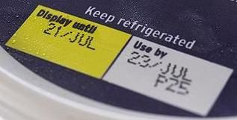
The ‘use by’ date is a really important one to take note of: after this date, the food may not be safe to eat. Foods that can cause harm when they go ‘off’ will be labelled with a use-by date.

TIP: ‘use by’ does not always mean ‘eat by’. If a food can be frozen, its life can be extended beyond the ‘use by date.
FACT: Eggs can be eaten after their ‘best before’ date as long as they are cooked thoroughly until both yolk and white are solid, or if they are used in dishes where they will be fully cooked such as a cake.
REMEMBER: The ‘best before’ date will only be accurate if the food is stored according to the instructions on the label, such as ‘store in a cool dry place’ or ‘keep in the fridge once opened’.

Facts about food waste
- In the UK our food waste amounts to 15m tonnes each year.
- 7m tones (47%) comes from household waste.
- 4.2m tonnes could have been saved and eaten and that’s enough to fill 8400 Olympic sized swimming pools.
- Almost half of this food goes straight from our fridges or cupboards to the bin and doesn’t even make it onto our dinner plates.
- Every day 24m slices of bread are thrown out and every year we throw out 86m whole chickens.
- The average UK family wastes £700 each year on food that could have been eaten but is thrown away. This is the equivalent of almost £60 a month to an average family or six meals every week.

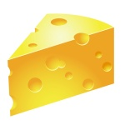
Foods that can be salvaged
Hard cheese
It’s safe to cut off the layer of mould and eat the mould-free cheese beneath it. Cheese is so dense that below the surface there isn’t enough oxygen to allow the mould to thrive. However, cut off a centimetre or so below the visible mould just to be sure of getting rid of it all.
Bread with small amounts of white and blue mould
The mould starts at the surface and grows down into the bread. The holes in bread mean that the mould can easily spread and so you need to cut off a good few centimetres beneath the mould before eating the rest. If you use a bread bin, make sure it’s free of old crumbs: if these go mouldy they can release spores which will contaminate the new bread. If you see orange, yellow and black mould spots then throw the bread away as these could be more harmful, and if there’s a lot of mould of any colour then that might give you a stomach ache!
Most fruits
Fruits are very acidic which prevents the growth of harmful bacteria but the acid won’t discourage mould. Most fruits are safe to eat once you’ve removed the mould. But if things have gone severely mouldy then handle them gently. You don’t want to release thousands of spores as you throw the fruit in the bin. However, there is one fruit to be wary of – apples. A certain kind of mould common on apples can produce a toxin called palatine which can be dangerous if enough is eaten. It’s normally a problem in the small quantities found in fruit (it is carefully monitored in apple juice where it could become more concentrated), but it’s best to avoid eating any mouldy parts on an apple.

How to make your food last longer
Saving money on your food shop doesn't stop at the supermarket. Allow your hard earned pennies to go even further by reading up on these simple yet effective tips that'll extend the life of your grub for longer.
That way, you’re keeping money in your pocket AND saving trips to the supermarket.
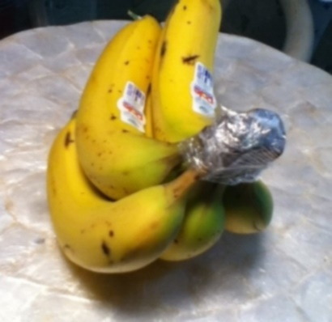

1. Wrap the crown of a bunch of bananas with cling film to keep them for 3-5 days longer.

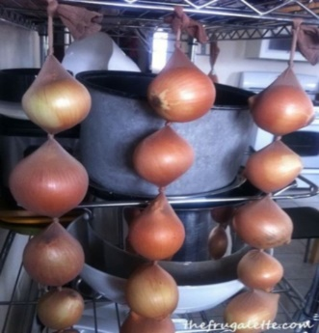

2. Onions stored in tights will last as long as 8 months.

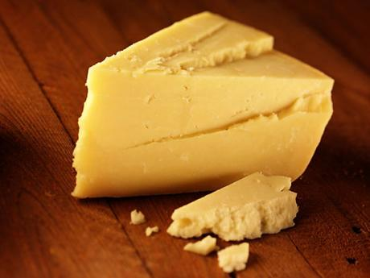

3. Butter the cut side of your cheese to stop it drying out.

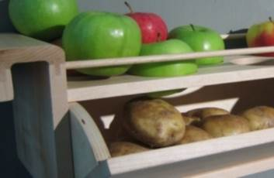

4. Store apples with potatoes to keep them from sprouting.

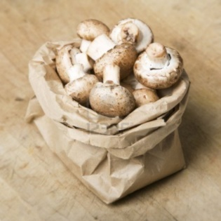

5. Store mushrooms in a paper bag, not a plastic one.

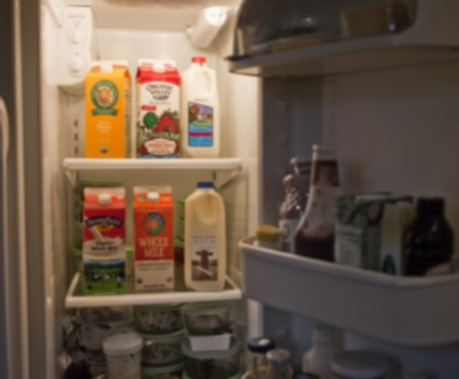

6. Keep milk in the middle of your fridge, NOT in the door where temperatures are cooler.

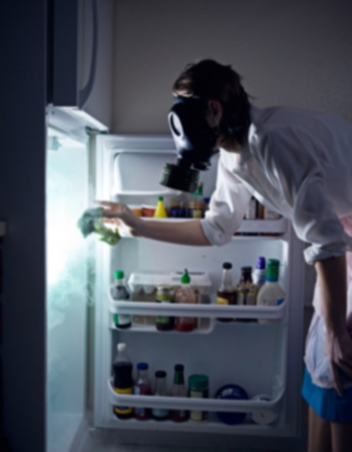

7. Clean your fridge. Once something goes rotten in your fridge or cupboard, bin it. The mold it leaves behind will soon spread to your new food. Also disinfect the fridge- it'll make everything keep for much longer.

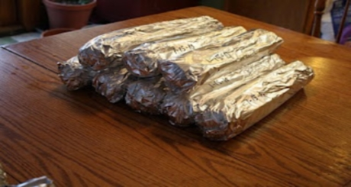

8. Wrap lettuce in tin foil to keep it crisp for longer.

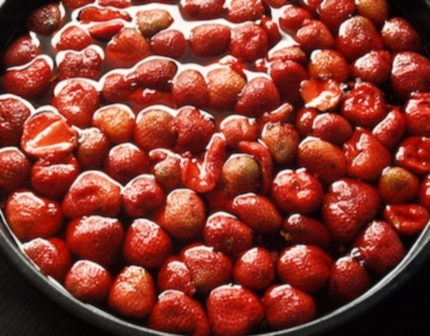

9. Rinse strawberries in vinegar. Swirl berries in a mixture of one part vinegar to 10 parts water. Drain, rinse and put in the fridge and voila! You can enjoy your strawberries for nearly 2 weeks longer. The solution is diluted enough so you won't taste the vinegar.

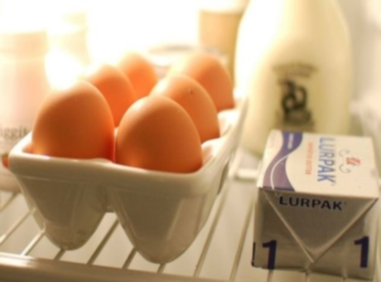

10. Store eggs in the middle shelf of the fridge to make them last 3-4 weeks past the sell by date. To check eggs are safe to eat place in water and if they float they are bad.

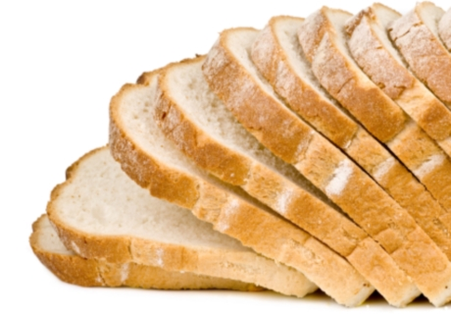

11. Freeze it. Take advantage of reductions at the supermarket by sticking them in the freezer. Freezing food will extend the life of most products including bread, cakes, and most fruit and veg (just make sure you put them in resealable bags or storage containers). So stock up and get freezing!
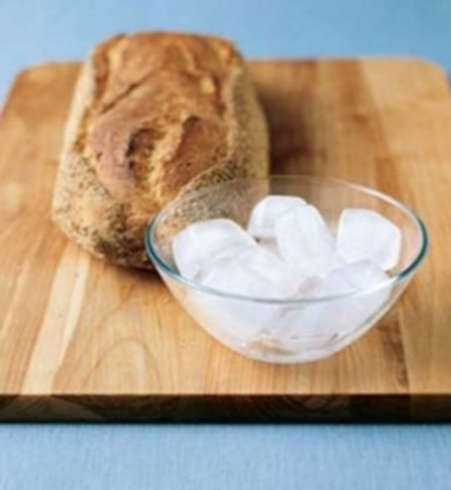

12. Rub an ice cube over stale bread, then bake for 12 minutes to revive it.

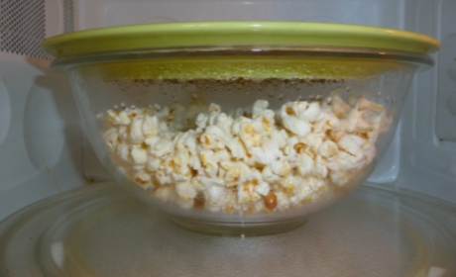

13. Reduce unpopped kernels by cooking popcorn in a bowl topped with a plate.

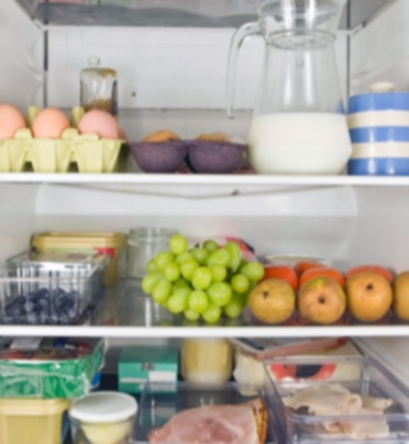

14. Keep older food at the front of the fridge so you can see what' needs to be eaten.

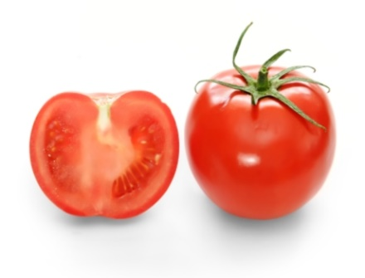

15. Store tomatoes at room temperature, not in the fridge.

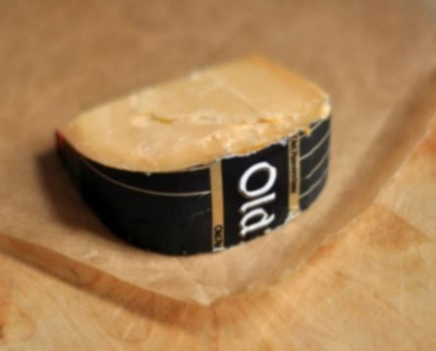
16. Keep cheese in the warmest part of the fridge, such as the vegetable or cheese draw.

18. And lastly....DON'T stick to best before dates. Best before dates are about quality, not safety. If stored right, you can in fact make an apple last a whole year.

