What is Digital Inclusion

Digital inclusion is a social issue. It is about having the skills and motivation to confidently go online to access the opportunities of the internet.
A lack of digital skills and access to online services can have a huge negative impact on a person’s life, leading to;

- Poorer health outcomes and a lower life expectancy.
- Increased loneliness and social isolation.
- Less access to jobs and education.
- Inability to claim for benefits and manage Universal Credit Journal.

It can mean:
- Paying more for essentials.
- Financial exclusion.
- An increased risk of falling into poverty.

Digitally excluded people also lack a voice and visibility in the modern world, as government services and democracy increasingly move online. What’s more, it often affects those already at a disadvantage - through age, education, income, disability, or unemployment - who are most likely to be missing out, further widening the social inequality gap.

11.3 million people in the UK don’t have the basic digital skills they need to thrive in today’s world. How much are they missing out on?

There are many online courses available for people who are able to access a computer and want to learn these skills.

Below is a useful website to get you started:

www.learnmyway.com

Digital Inclusion and claiming benefits

With the introduction of Universal Credit which many people in Sandwell and Dudley already claim, and which will replace legacy working age benefits, online access has never been so important. Universal Credit has to be claimed for online. Everyone who is in receipt of Universal Credit will need to access their online account and manage the benefit on a regular basis.

Click Start

Black Country Housing Group is delivering the Black Country Click Start project, a free service for people who are unemployed (not on zero hours contracts) or ‘economically inactive’ e.g. not in work, self-employment and are not available for or not seeking work. The aim is to help people to develop their personal financial and digital skills to enable them to make the most of the internet, manage their money and find training, volunteering or employment opportunities online.

Funded by the European Social Fund and the Big Lottery Fund, the project specifically targets people not in work who are or will be affected by a change in circumstances such as a transfer to Universal Credit.

Delivered in small groups or one to one sessions, support is offered with any of the following:

- Help to log into a Universal Credit account.
- Filling out online forms.
- Staying safe online.
- Accessing employment support and training information online.
- Applying for jobs and volunteering opportunities online.
- Comparing products online to save money.
- Budget planning.
- Receiving and sending e-mails.
- Using social media e.g. Facebook, Twitter and WhatsApp.
- Making/receiving telephone/video calls using Skype, Face time, WhatsApp.
- Finding information online about leisure activities i.e. cinema times, holiday bookings, music videos, You tube.
- Watching TV online or downloading TV programmes or films, Netflix.
- Accessing specific health support needs online.
- Setting up online billing and banking.

We will provide support at a local library, community centre or community venue.

If you need help or would like to find out more about the project, please contact the team on:
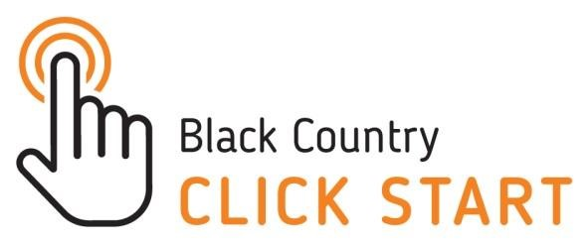
0121 561 7935
07969 559155
bbo-clickstart@bchg.co.uk

