DHP & LWP

Discretionary Housing Payments (DHP)
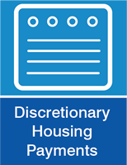
If you get Housing Benefit or the Housing Element of Universal Credit, but you're still finding it difficult to meet the shortfall in your rent (the difference between how much you get in benefit and how much your rent actually costs) then you may be entitled to some help.
This is called a Discretionary Housing Payment or DHP.

Each application for DHP is considered on the individual merits of the case. Payments will usually be awarded if you can show that you are experiencing financial hardship, or you have some other special circumstances causing you difficulty paying your rent.
You can also get a DHP if
- You need help to cover the cost of a deposit on a new property.
- You need help to move into a new property.
- You are struggling to pay your rent due to a nondependent charge on your Housing Benefit. In this situation you can apply on behalf of your nondependent.

You can apply online to get help through DHP. You will need to give details of your financial situation and any other information you feel is relevant.

To apply to SMBC for a DHP visit –
http://www.sandwell.gov.uk/info/200154/housing_benefit/2170/problems_with_paying

To apply for DHP with Dudley visit:
www.dudley.gov.uk/residents/benefits/discretionary-housing-payments

Local Welfare Provision
From 1st April 2013 the Welfare Reform Act abolished Crisis Loans and Community Care Grants administered by the Department for Works and Pensions (DWP).
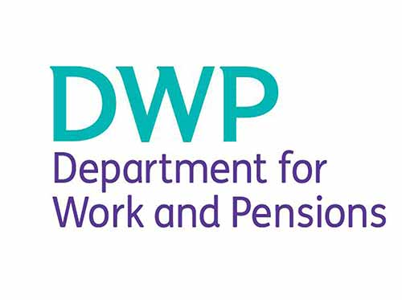
As an alternative, the DWP gave funding to local authorities to provide a new Local Welfare Provision, however funding was only provided for two years and there is no statutory requirement for Councils to provide a scheme.
On 1 April 2013 Sandwell Council introduced a Local Welfare Provision Scheme (LWP).

The scheme aims to provide support where:
- A household does not have enough resources to meet an urgent need or crisis that poses an immediate and substantial risk to their health and safety. A crisis is an urgent need because of an emergency, disaster, unforeseen circumstance or a pressing need that is strikingly different from the normal pressures associated with managing on a low income.
- Someone is leaving care and needs essential household items to establish themselves in the community.
- Someone needs essential household items to set up a home as part of a planned resettlement program.
The scheme is purely discretionary and people have no automatic right to an award.
To be able to get assistance through Sandwell’s LWP scheme, customers must:
- Be aged 18 or over.
- Have been living in Sandwell immediately before requesting assistance.
- Be receiving one of the following benefits:
  - Income Support.
  - Income based Jobseeker's Allowance.
  - Income related Employment and Support Allowance.
  - Pension Credit (Guarantee Element only).
  - Universal Credit – Where you qualify for the full Allowance (i.e. There are no deductions for employment).
We cannot normally award LWP if your benefits have been delayed or sanctioned unless there are exceptional reasons.

Sandwell’s LWP scheme can provide help with the following:
- Food – This will be a food voucher that can be used at one of the local food banks and gives emergency provision for three days.
- Fuel – This will be a pay point voucher for pre pay meters only and gives emergency provision for three days.
- Travel – This will be a payment voucher for one to three days travel in the West Midlands area only.
- Furniture / White Goods – All furniture will be good second hand furniture except for white goods and mattresses. These goods will be provided by one of our voluntary sector suppliers.
We deliver support through the voluntary sector in order to be able to help as many people as we can. Each claim is restricted to no more than two awards within a rolling 12 month period. To request help through our LWP scheme please call into one of the Housing Services Centres where a member of staff will be able to complete a referral.

There is no Local Welfare Provision in Dudley

Housing Service Centres in Sandwell

For local help with housing issues you can email or call:

customer_services@sandwell.gov.uk
0121 368 1166

Alternatively you can visit one our six local centres:

Oldbury Local Centre
Sandwell Council House
Freeth Street
Oldbury
B69 3DE

Opening hours: Monday, Tuesday and Thursday 8.45am-5.30pm, Wednesday 9am-5.30pm.
Friday 8.45am-5pm.
Cashiers opening hours (for making payments): Monday, Tuesday, Thursday 8.45am-4.45pm, Wednesday 9.00am-4.45pm, Friday 8.45am-4.45pm.

Rowley Regis Local Centre
Payne Street
Blackheath
B65 0DH

Opening hours: Monday to Friday 9am-5pm.
Cashiers opening hours (for making payments): Monday to Friday 9am-4.30pm.

Smethwick Local Centre
Ground Floor
Smethwick Council House
High Street
Smethwick
B66 3NT

Opening hours: Monday to Friday 9am-5pm
Cashiers opening hours (for making payments): Monday to Friday: 10am to 2pm

Tipton Local Centre
High Street
Princes End
Tipton
DY4 9JB

Opening hours: Monday to Friday 9am-5pm.
Please note: this office no longer has a cash office facility.

Wednesbury Local Centre
Ground Floor
Wednesbury Town Hall
Holyhead Road
Wednesbury
WS10 7DF

Covers Wednesbury, Leabrook, Golf Links, Woods Mesty and Friar Park.
Opening hours: Monday to Friday 9am-5pm.
Cashiers opening hours (for making payments): Monday to Friday 9am-4.30pm.

West Bromwich Local Centre
Court House
High Street
West Bromwich
B70 8LU

Covers West Bromwich, Greets Green, Tantany, Black Lake, Stone Cross, Yew Tree, Great Barr and Hamstead.
Opening hours: Monday to Friday 9am-5pm.
Please note: this office no longer has a cash office facility.
Contact us at: lwp_operations@sandwell.gov.uk

For further information about Sandwell Councils LWP policy visit:

www.sandwell.gov.uk/info/200145/benefits_and_grants/2576/local_welfare_provision

Housing Service Centres in Dudley

For local help with housing issues you can call:

0300 555 2345

Or visit –

Dudley Council Housing Services
Harbour Buildings Waterfront West,
Dudley Rd,
Brierley Hill
DY5 1LN

