Budgeting

What items should go into your budget

Absolutely everything that affects you financially. People always include the major items like wages or benefits for income but are you including any interest from savings or any pensions? With your spending, you may be including regular bills like water, gas and electricity but are you keeping track of that bottle of milk and a loaf that you get from the corner shop when you’ve run out? How about the takeaways, the coffee shop and the trip to McDonald’s?

EVERYTHING you buy HAS to be included in a budget sheet, even the bottle of milk, loaf or cigarettes from the corner shop that you buy in an emergency. You may want to use a spending diary or a budgeting app on your phone to record this sort of purchase.

This will give you an idea of ‘regular’ spending but may not include things like car tax or insurance, Christmas, holidays, weddings etc. which are less regular items. You will have to make a note of these separately for the time being.

When you’ve added the less regular items together, you then need to break them down into the same time frequency as the items already in your budget. If all the items in your budget sheet are weekly items, make sure all the less regular items are broken down into weekly amounts and added onto the budget sheet.

How to create a budget?
Total your monthly expenses - Make a list of all of your regular monthly expenses, including any money that you spend on fun things like eating out, entertainment and hobbies; and any minimum payments that you have to make towards your debts. Remember to include money towards any bills that are paid quarterly or yearly, not just things you use weekly or monthly. If you are unsure about your daily spending, keep a spending diary for two weeks and record absolutely everything you spend money on during this time. This includes things from the corner shop, treats for the kids, emergency money put on the meter, etc. Add up everything to reach a total amount for your spending.
You may record your expenses on a weekly basis if you prefer but make sure that you also record your income/earnings (see below) over the same period of time.
Total your income - List how much you receive each month including any money that you receive from wages or benefit payments.

Add up everything to reach a total amount for your income. Only include regular income, not things like overtime as this can vary from month to month and some months you may not get any!
Subtract expenses from income - Subtract (take away -) your monthly expenses from your income. This will show you how much you can expect to have left at the end of the week/month.
Re-calculate your budget - If you’re spending more than you receive, change the amount you spend until it’s at least the same as your income. To do this, you will have to go back over each item of spending realistically e.g. food spending and look for ways to cut down. How can you cut back? Spending £3.00 on a coffee every week day adds up to £780 a year.
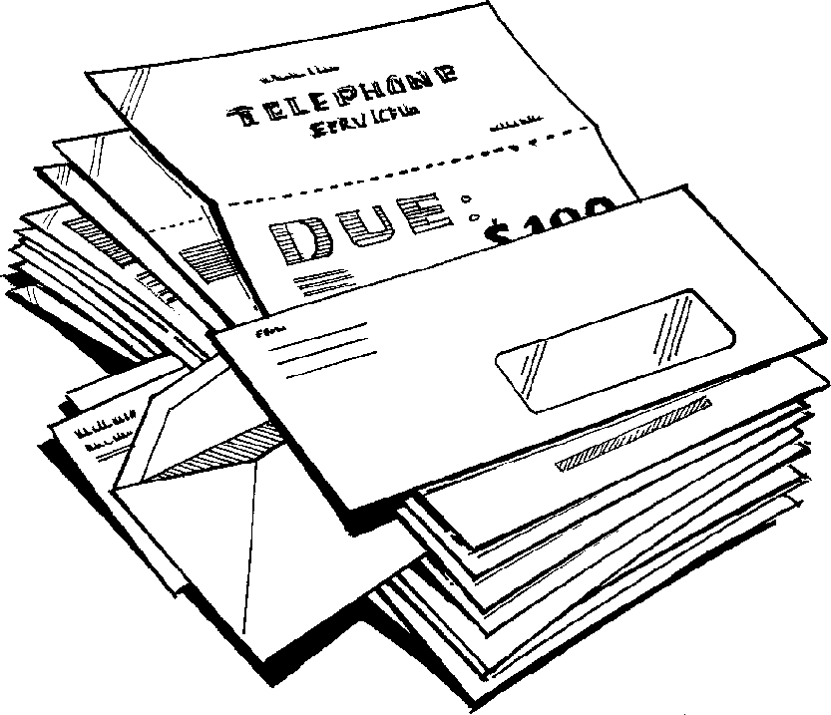
Allow money for debt reduction - If you have debts or outstanding bills, your budget should already include the minimum payments that you have to make each month. To reduce the outstanding amount more quickly, you would need to look at your budget again to see if there is anywhere you are able to make sacrifices so that you are left with more money to pay off your debts.
Build in your savings - Now it’s time to budget money for your financial goals. Will you feel better if you have the security of an emergency fund? Do you want to prepare for the introduction of Universal Credit? Save for a holiday or other special occasion? Make a list of what you hope to achieve, and then look at your budget once more to try to find the money that you need to reach those goals.
If you have a lot of debt, you may need to put any plans to save on hold. Remember, debt reduction should be your first priority.
See if your budget works - Once you’ve created a budget that covers all of your monthly expenses and financial goals, it’s time to put your budget to the test. Try to live within your budget for a week or month and see how it works out.
Check your budget - At the end of every week or month, check your outgoings (spending) to see if they are matching up to your budget. If they aren’t, is it because your budget is unrealistic and needs to be re-calculated to reflect your actual spending? Is it because you’re buying extra things you don’t need? Have you forgotten to include things in your budget?

Check your budget again! A good budget is never finished. Check it every month to see if there are areas of overspending or if your income has fallen.

Tips
- Be honest about your spending habits and you’ll end up with a much more realistic budget.
- Try to budget for the occasional treat. Budgeting doesn’t mean going without nice things. You are much more likely to stick to a budget if you have something to look forward to.
- So, make sure you have a copy of your bills, a calculator, pen/pencil and blank budget sheets, make yourself comfortable and begin.
Prioritising your spending
To manage your money well, it is important to prioritise your spending (decide which items are most important). This may vary from person to person but here is a general guide.
First, pay your bills. Make sure your most important expenses (priority bills) are covered each month – e.g. rent or mortgage, utility bills (gas, water and electricity)
Then pay your day-to-day needs, like food and travel.
Occasional costs come up every three months or every year. Make sure you have:
- Put money aside to pay for those.
- Save some money for emergencies. Unexpected situations can occur and it is
  - helpful to have an emergency fund.
- When you have covered all these expenses, the next step would be to save money for future plans such as buying a house, education and so on.
If you’re using a budget to help you to achieve a target or goal, make sure it is a
SMART target: Specific, Measurable, Achievable, Relevant, and Time Framed
E.g. if you’re saving for a new telly and the telly is likely to cost £300 and you’re likely to need it within a year, how much must you save and for how long? If you can save £6 per week, how long will you need to save for to be able to buy the telly?
(Answer £300 ÷ 6 = 50 weeks!)

It is a SMART target because it’s:
- Specific – it’s for the telly which you know you’ll need sooner than later
- Measurable – you’ll need £300
- Achievable – you can afford £6 per week because you’ve put this in the budget
- Relevant – everyone will moan if you haven’t got a telly
- Time framed – you’ll need it within a year

How to do calculations for your budget
To turn an annual bill into weekly or monthly amounts e.g. Home insurance buildings and contents cover costing £400.
£400 ÷ 52 weekly payments = £7.69 per week
£400 ÷ 12 monthly payments = £33.33 per month

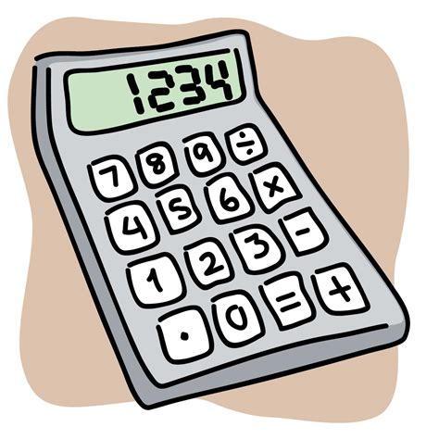
To turn weekly payments into monthly amounts e.g. rent of £80 per week:
£80 x 52 weeks = £4160 which is the yearly total
£4160 ÷ 12 monthly payments = £346.67 per month

To turn fortnightly payments into monthly amounts e.g. Employment and Support Allowance of £200 per fortnight:
£200 x 26 (fortnights in a year) = £5200
£5200 ÷ 12 monthly payments = £433.33 per month

To turn four weekly payments into monthly amounts e.g. Child benefit of £82 every four weeks
£82 x 13 (four week periods in a year) = £1066
£1066 ÷ 12 monthly payments = £88.83 per month

you’ve got it | you want it | times by | divide by
weekly | fortnightly | 2 | n/a
weekly | monthly | 52 | 12
fortnightly | weekly | n/a | 2
fortnightly | monthly | 26 | 12
monthly | weekly | 12 | 52
monthly | fortnightly | 12 | 26
quarterly | weekly | 4 | 52
quarterly | fortnightly | 4 | 26
quarterly | monthly | 4 | 12
half-yearly | weekly | 2 | 52
half-yearly | fortnightly | 2 | 26
half-yearly | monthly | 2 | 12
yearly | weekly | n/a | 52
yearly | fortnightly | n/a | 26
yearly | monthly | n/a | 12
Making your budget match your bill

Useful Budgeting Tools

We suggest you have a look at each one of these websites and see what suits your needs:

- The National Debt line
www.tools.nationaldebtline.org/yourbudget

- The Money Advice Service
www.moneyadviceservice.org.uk/en/tools/budget-planner

- Money Saving Expert
www.moneysavingexpert.com/banking/Budget-planning#free

- Citizens Advice
www.citizensadvice.org.uk/debt-and-money/budgeting/budgeting/work-out-your-budget

- Sandwell Better Off
www.sandwell.betteroff.org.uk/#/home

This can be a good way to get you looking at budgeting in an interactive way.

Apps
If you have a smartphone there are some very good budgeting apps that can be downloaded and used. Examples include;

- Wonderbill
- Yolt
- Fudget
- Money Monitor
- Bills Monitor
- Money manager

Priority bills and methods/frequency of payments

Rent
Method | Direct Debit/Phone/In Person/ Post/ Standing Order/Online
Frequency | Weekly/Monthly – Rent should be paid in advance rather than arrears. Particularly if you are paying monthly.  Under Universal Credit, tenants who are currently having their housing benefit paid directly to their landlord will have it paid to them instead and will be responsible for paying their own rent to their landlord.

Council Tax
Method | Direct Debit/Online/Telephone/In Person/Standing Order
Frequency | You can choose to pay on the 5th, 15th or 28th of the month and you can choose to pay in either 10 or 12 monthly instalments.

Electricity/Gas
Method | Direct Debit/Cash/Cheque/Payment Card/Prepayment Meter/Fuel Direct
Frequency | Quarterly/Monthly/Weekly/Pay as you go – Depends on type of meter to property

TV Licence – currently £150.50 per year
Method | Direct Debit/Online/Paypoint/Payment Card/Savings Cards/Cheque/ Postal Order/ BACS
Frequency | You'll usually pay for your first licence within six months, in instalments of around £25 per month. (If we have to spread the cost into four or five monthly instalments, each payment may be slightly higher). From then on, you pay for your licences in 12 monthly instalments of just over £12.50 - six before your licence is due and six after.  Just one of the ways to help make paying more convenient at no extra cost.  You pay instalments of around £37.50 every three months. By paying quarterly the majority of your licence is paid for as you use it. This differs from our other instalment schemes, where at least half of the licence fee is collected in advance. As a result, quarterly payments incur a small premium of £1.25 per quarter which is included in your payment.

Water
Method | Direct Debit / Online/By Phone/Paypoint/At Post Office/At Bank/Post
Frequency | Yearly/Monthly/Weekly

